Lab program-06(Order-processing datadbase)

Customer table:

create table customer(

cust_no int not null,

cname varchar(30),

city varchar(20),

primary key(cust_no));

Order table:

create table order1(

order_no int not null,

odate date,

cust_no int,

ard_amt real,

primary key(order_no),

foreign key(cust_no) references customer(cust_no));

Item table:

create table item(

item_no int not null,

unit_price real,

primary key(item_no));

Order-item table:

create table orderitem(

order_no int not null,

item_no int not null,

qty int,

primary key(order_no,item_no),

foreign key(order_no) references order1(order_no),

foreign key(item_no) references item(item_no));

Warehouse table:

create table warehouse(

warehouse_no int not null,

city varchar(20),

primary key(warehouse_no));

Shipment table:

create table shipment(

order_no int not null,

warehouse_no int not null,

ship_date date,

primary key(order_no,warehouse_no),

foreign key(order_no) references order1(order_no),

foreign key(warehouse_no) references warehouse(warehouse_no));

Customer Order

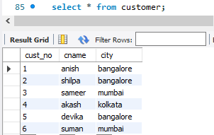 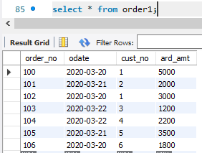

Item Order-item

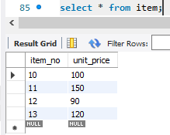 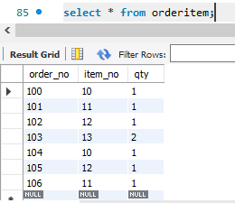

Warehouse: Shipment:

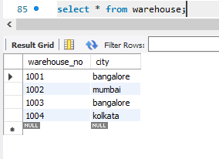 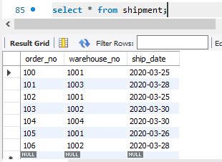

Query-1:

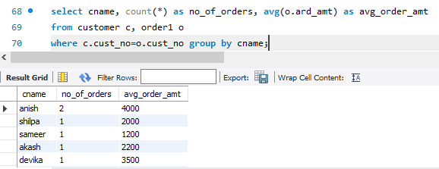

Query-2:

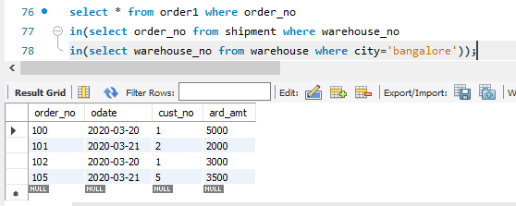

Lab program-07(Book dealer database)

Author table:

create table author(

author_id int not null,

aname varchar(30),

city varchar(20),

country varchar(20),

primary key(author_id));

Publisher table:

create table publisher(

pub_id int not null,

pname varchar(30),

city varchar(20),

country varchar(20),

primary key(pub_id));

Category table:

create table category(

category_id int not null,

descriptionn varchar(30),

primary key(category_id));

Catalog table:

create table catalog(

book_id int not null,

title varchar(30),

author_id int not null,

pub_id int not null,

category_id int not null,

year int,

price real,

primary key(book_id),

foreign key(author_id) references author(author_id),

foreign key(pub_id) references publisher(pub_id),

foreign key(category_id) references category(category_id));

Order-details table:

create table order_details1(

order_no int not null,

book_id int ,

quantity int,

primary key(order_no),

foreign key(book_id) references catalog(book_id));

Author table: Publisher table:

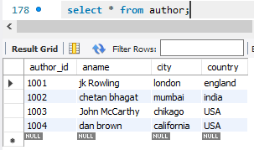 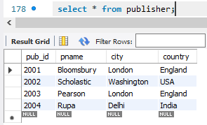

Category table: Order table:

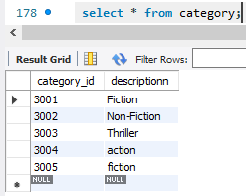 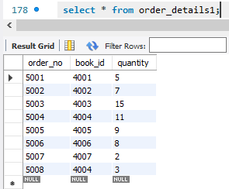

Query-1:

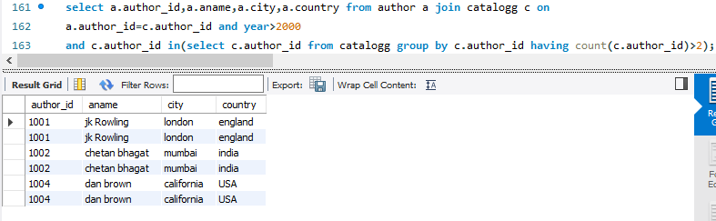

Catalogue table:

: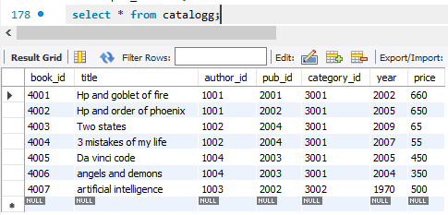

Query-2:

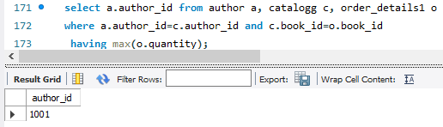

Query-3:

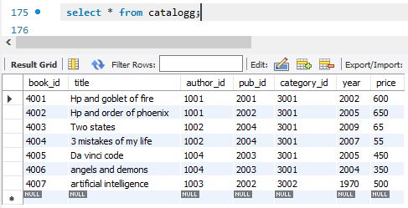

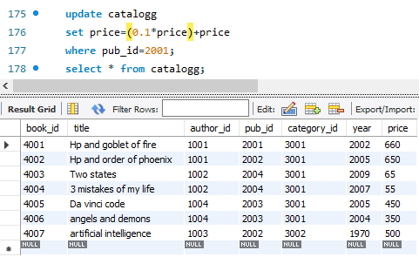

Lab program-08(Student_Enrollment database)

Student table:

create table student1(

reg_no varchar(10) not null,

sname varchar(30),

major varchar(10),

bdate date,

primary key(reg_no));

Course table:

Create table course(

Course_no int not null,

Cname varchar(30),

Dept varchar(10),

Primary key(course_no));

Enroll table:

Create table enroll(

Reg_no varchar(10) not null,

Course_no int not null,

Sem int,

Marks int,

Primary key(reg_no,course_no),

Foreign key(course_no) references course(course_no));

Text table:

Create table text(

Book_ISBN int not null,

Book_title varchar(30),

Publisher varchar(30),

Author varchar(30),

Primary key(book_ISBN));

Book_Adoption table:

Create table book_adoption(

Course_no int not null,

Sem int,

Book_ISBN int not null,

Primary key(course_no,book_ISBN),

Foreign key(course_no) references course(course_no),

Foreign key(book_ISBN) refrerences text(book_ISBN));

Student table: Course table: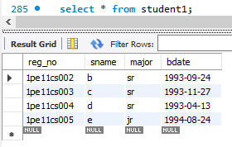 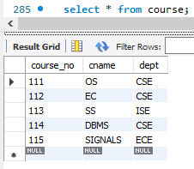

Enroll table: Text table:

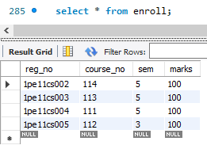 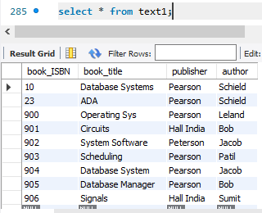

Book_adoption table: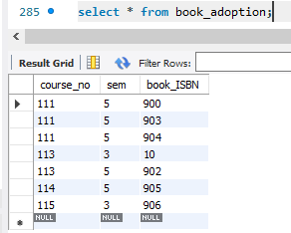

Query-1:

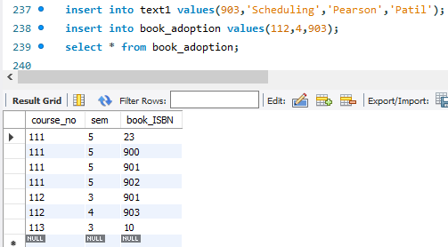

Query-2:

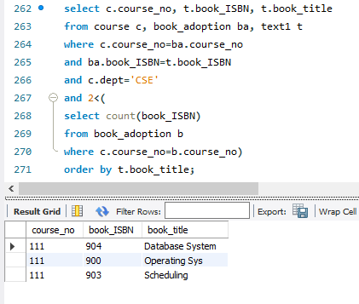

Query-3:

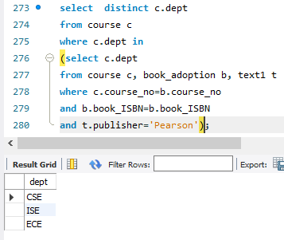

Lab program-09(Airline flight database)

Flight table:

Create table flight(

flno int not null,

f_from varchar(20),

f_to varchar(20),

distance int,

departs time,

arrives time,

price int,

primary key(flno));

Aircraft table:

Create table aircraft(

aid int not null,

aname varchar(30),

cruisinrange int,

primary key(aid));

Certified table:

Create table cerified(

eid int not null,

aid int not null,

primary key(eid,aid),

foreign key(eid) refrences employee(eid),

foreign key(aid) refrences aircraft(aid));

Employee table:

Create table employee(

eid int not null,

ename varchar(30),

salary int,

primary key(eid));

Flight table:

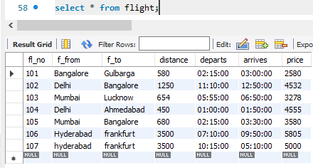

Aircraft table:

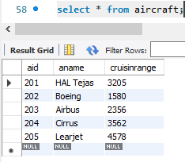

Certified table:

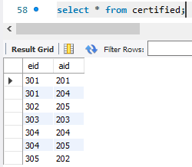

Employee table:

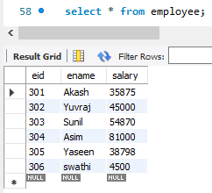

Query-1:

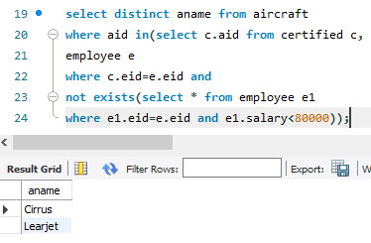

Query-2:

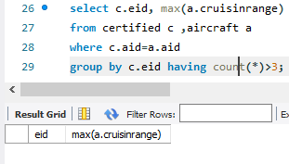

Query-3:

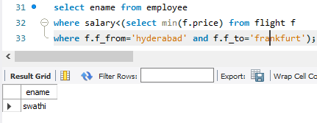

Query-4:

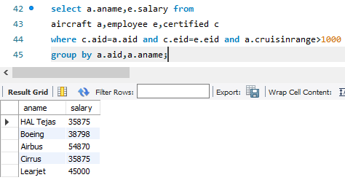

Query-5:

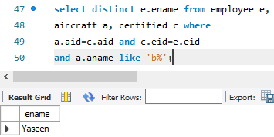

Lab program-10(college database)

Student table:

create table student(

usn varchar(10) not null,

sname varchar(30),

address varchar(30),

phone int,

gender varchar(5),

primary key(usn));

Semsec table:

create table semsec(

ssid varchar(10),

sem int,

sec varchar(5),

primary key(ssid));

Class table:

create table class(

usn varchar(10),

ssid varchar(10),

primary key(usn,ssid),

foreign key(usn) references student(usn),

foreign key(ssid) references semsec(ssid));

Subject table:

create table subject(

subcode varchar(10),

title varchar(20),

sem int,

credits int,

primary key(subcode));

IA_marks table:

create table IA_marks1(

usn varchar(10),

subcode varchar(10),

ssid varchar(10),

test_1 int,

test_2 int,

test_3 int,

final_IA int,

foreign key(usn) references student(usn),

foreign key(ssid) references semsec(ssid),

foreign key(subcode) references subject(subcode));

Student table: Semsec table:

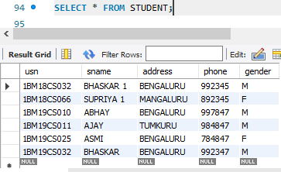 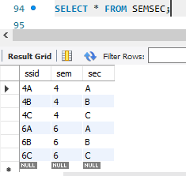

Class table: Subject table:

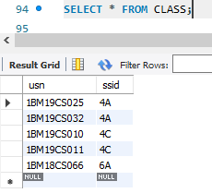 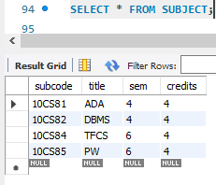

IA_Marks table:

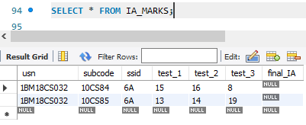

Query-1:

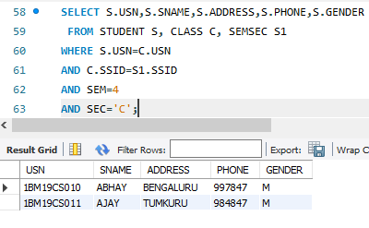

Query-2:

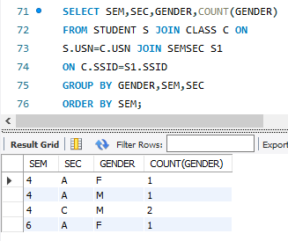

Query-3:

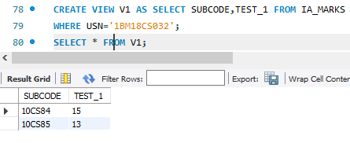

Query-4:

